Author: Mahesh Santosh Bhakare

Employee ID: API2309

Batch: Greenfield Training Batch 31

C PROGRAMMING -

Title: 1. Program to check weather number is perfect number or not.

**Source Code:**

#include<stdio.h>

void checkPrefect(int num)

{

int sum=0,i=1;

while(i<num)

{

if(num%i==0)

{

sum+=i;

}

i++;

}

if(sum==num)

{

printf("number is a perfect number \n");

}

else

{

printf("number is not a perfect number \n");

}

}

void main()

{

int num;

printf("enter the number: ");

scanf("%d",&num);

checkPrefect(num);

}

**Output:**

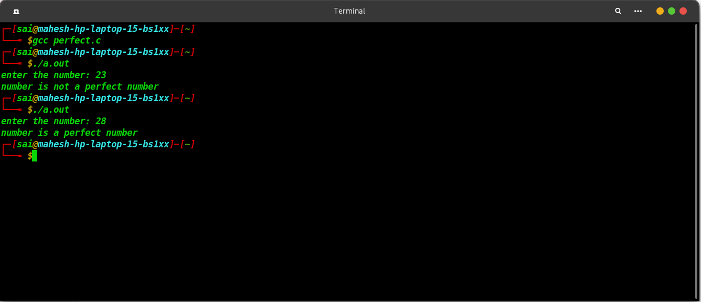

Title: 2. Program to check weather number is Prime number or not.

**Source Code:**

#include<stdio.h>

void checkPrime(int n)

{

int i=2;

if(n==1)

{

printf("%d is not a prime number.\n",n);

}

while(i<=n)

{

if(n%i==0)

{

if(n==i)

{

printf("%d is a prime number.\n",n);

}

else

{

printf("%d is not a prime number.\n",n);

break;

}

}

i++;

}

}

void main()

{

int n;

printf("enter the number to check whether it is prime or not: ");

scanf("%d",&n);

checkPrime(n);

}

**Output:**

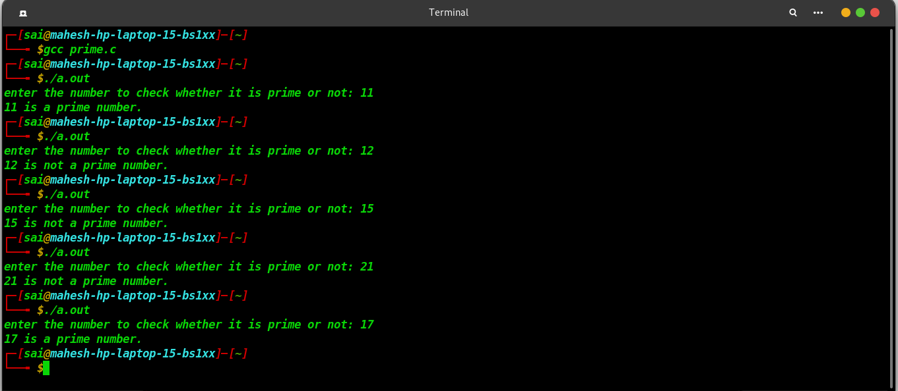

Title: 3. Program to check weather number is Armstrong number or not.

**Source Code:**

#include<stdio.h>

void checkArmstrong(int num)

{ int num2=num,i=0,sum=0,mult,value;

// to find the no. of digits in a number

while(num2!=0)

{

num2/=10;

i++;

}

// to find the armstrong value

num2=num;

while(num2!=0)

{

value= num2%10;

mult=1;

for(int j=1;j<=i;j++)

{

mult*=value;

}

sum+=mult;

num2/=10;

}

// to check the armstrong or not

if(sum==num)

{

printf("the number is armstrong number\n");

}

else

{

printf("the number is not an armstrong number\n");

}

}

void main()

{

int num;

printf("enter the number: ");

scanf("%d",&num);

checkArmstrong(num);

}

**Output:**

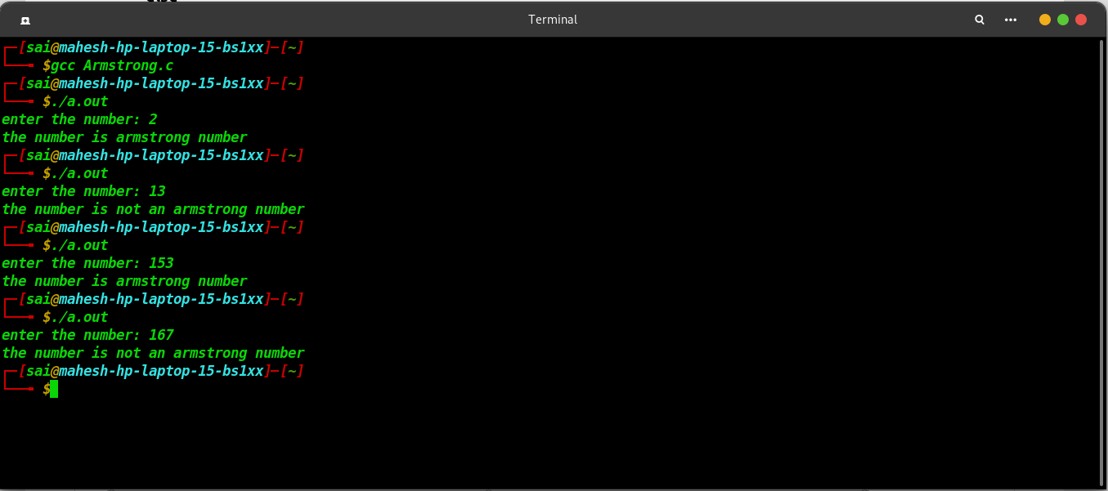

Title: 4. Program to print febonici series upto n numbers.

**Source Code:**

#include<stdio.h>

void printFibonacii(int num)

{

int i=0,j=1,k;

if(num>0)

{

printf("%d\t",0);

}

while(num>1)

{

k=i;

i=i+j;

printf("%d\t",i);

j=k;

num--;

}

printf("\n");

}

void main()

{

int num;

printf("enter the number: ");

scanf("%d",&num);

printFibonacii(num);

}

**Output:**

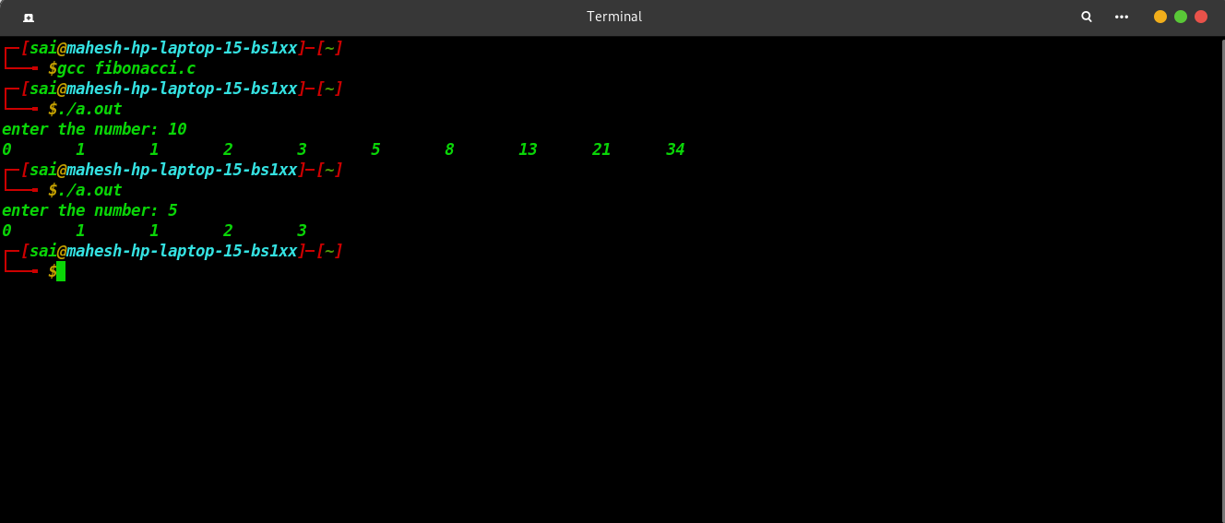

C++ PROGRAMMING -

Title: 1. Program to check weather number is perfect number or not.

**Source Code:**

#include<iostream>

using namespace std;

bool checkPrefect(int num)

{

int sum=0,i=1;

while(i<num)

{

if(num%i==0)

{

sum+=i;

}

i++;

}

if(sum==num)

{

return true;

}

else

{

return false;

}

}

int main()

{

int num;

cout<<"enter the number: ";

cin>>num;

if(checkPrefect(num))

{

cout<<"number is a perfect number..."<<endl;

}

else

{

cout<<"number is not a perfect number..."<<endl;

}

return 0;

}

**Output:**

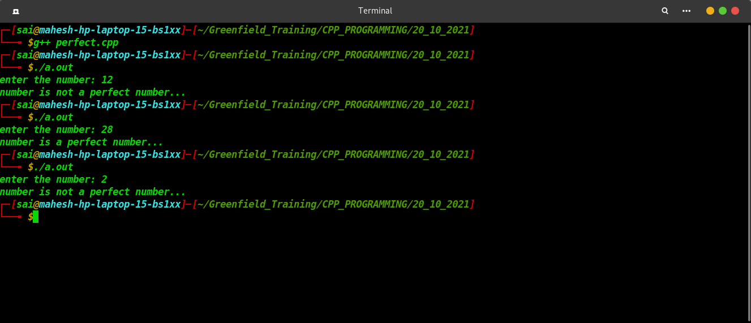

Title: 2. Program to check weather number is Prime number or not.

**Source Code:**

#include<iostream>

using namespace std;

class Prime

{

int num;

public:

Prime(int num)

{

this->num = num;

}

void checkPrime()

{

int i=2;

if(this->num==1)

{

printf("%d is not a prime number.\n",this->num);

}

while(i<=this->num)

{

if(this->num%i==0)

{

if(this->num==i)

{

printf("%d is a prime number.\n",this->num);

}

else

{

printf("%d is not a prime number.\n",this->num);

break;

}

}

i++;

}

}

};

int main()

{

Prime p(2);

Prime q(28);

p.checkPrime();

q.checkPrime();

return 0;

}

**Output:**

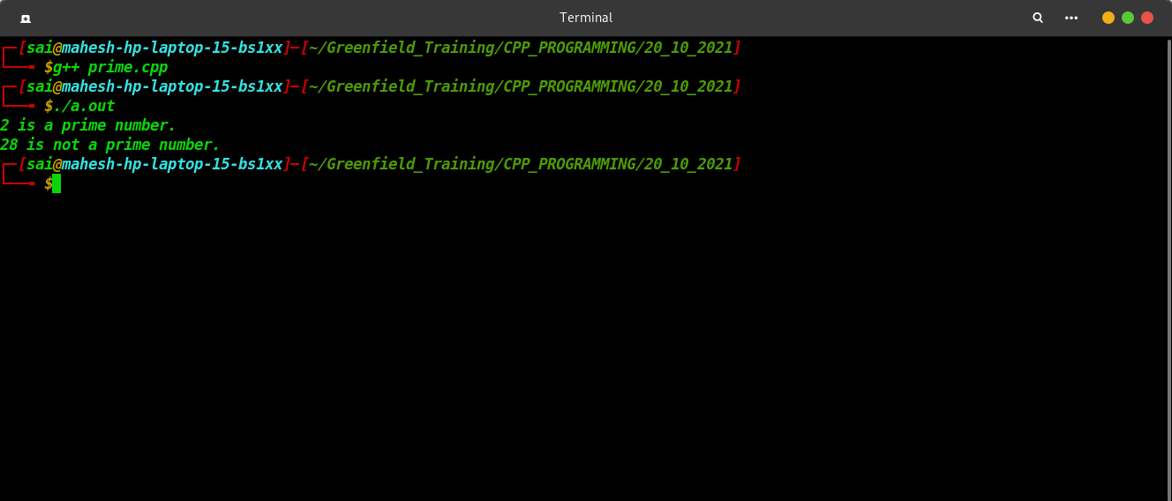

Title: 3. Program to check weather number is Armstrong number or not.

**Source Code:**

#include<iostream>

using namespace std;

bool checkArmstrong(int num)

{ int num2=num,i=0,sum=0,mult,value;

// to find the no. of digits in a number

while(num2!=0)

{

num2/=10;

i++;

}

// to find the armstrong value

num2=num;

while(num2!=0)

{

value= num2%10;

mult=1;

for(int j=1;j<=i;j++)

{

mult*=value;

}

sum+=mult;

num2/=10;

}

// to check the armstrong or not

if(sum==num)

{

return true;

}

else

{

return false;

}

}

int main()

{

int num;

printf("Enter the number: ");

cin>>num;

if(checkArmstrong(num))

{

cout<<"The number is an armstrong number"<<endl;

}

else

{

cout<<"The number is not an armstrong number"<<endl;

}

return 0;

}

**Output:**

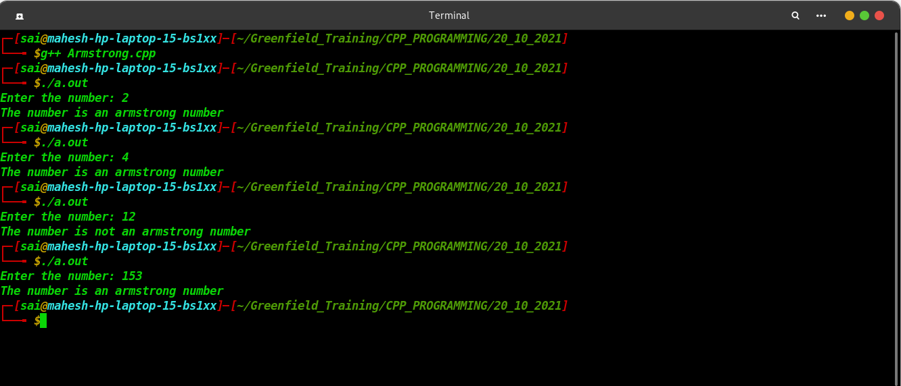

Title: 4. Program to print febonici series upto n numbers.

**Source Code:**

#include<iostream>

void printFibonacii(int num)

{

int i=0,j=1,k;

if(num>0)

{

std::cout<<0<<"\t";

}

while(num>1)

{

k=i;

i=i+j;

std::cout<<i<<"\t";

j=k;

num--;

}

std::cout<<std::endl;

}

int main()

{

int num;

std::cout<<"Enter the number: ";

std::cin>>num;

printFibonacii(num);

}

**Output:**

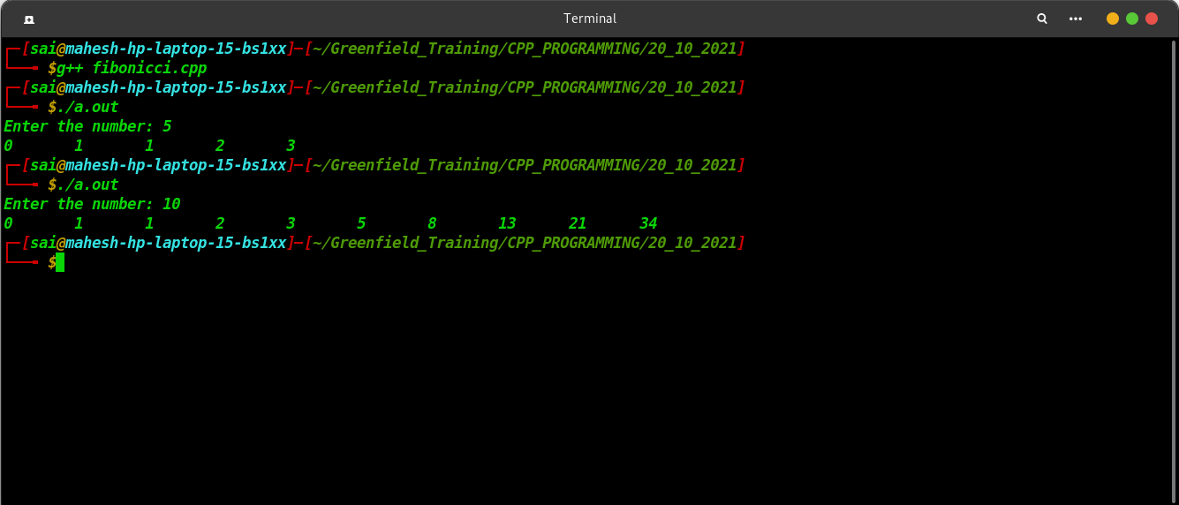

JAVA PROGRAMMING -

Title: 1. Program to check weather number is perfect number or not.

**Source Code:**

**package** com.apisero.greenfield;

**import** java.util.Scanner;

**public** **class** Perfect

{

**boolean** checkPrefect(**int** num)

{

**int** sum=0,i=1;

**while**(i<num)

{

**if**(num%i==0)

{

sum+=i;

}

i++;

}

**if**(sum==num)

{

**return** **true**;

}

**else**

{

**return** **false**;

}

}

**public** **static** **void** main(String[] args)

{

**int** num;

**char** ch='y';

Perfect p = **new** Perfect();

Scanner sc = **new** Scanner(System.***in***);

**while**(ch == 'y')

{

num = sc.nextInt();

**if**(p.checkPrefect(num))

{

System.***out***.println("Number is a Perfect Number");

}

**else**

{

System.***out***.println("Number is not a Perfect Number");

}

System.***out***.print("Want to check Another Number: ");

ch = sc.next().charAt(0);

}

}

}

**Output:**

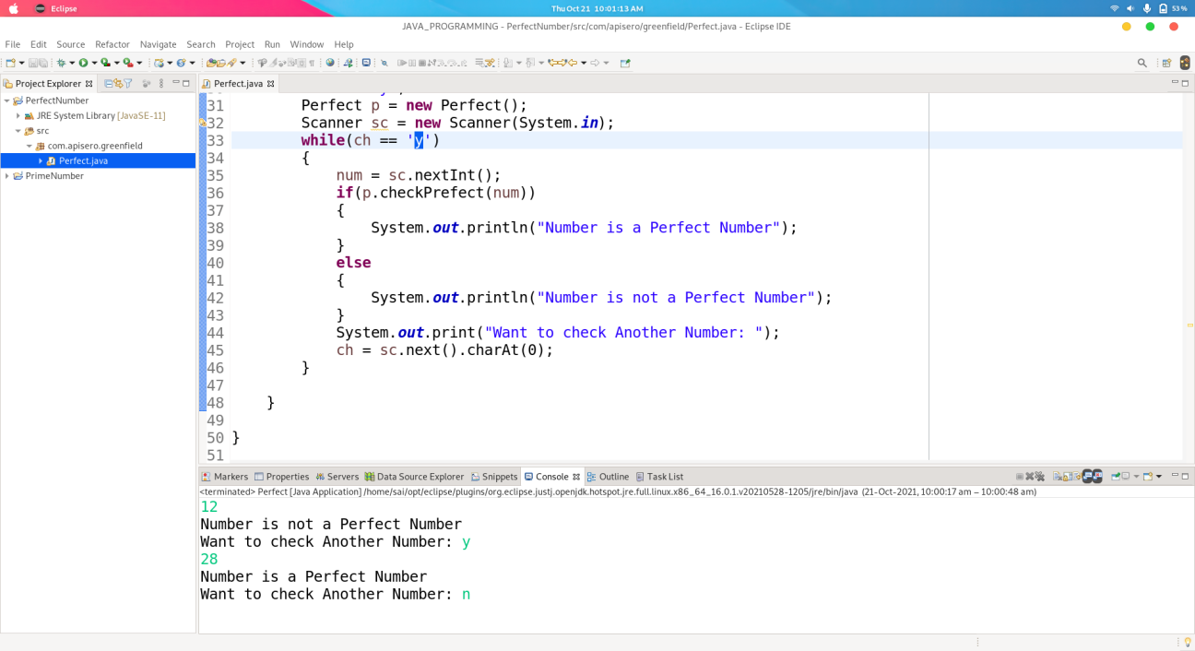

Title: 2. Program to check weather number is Prime number or not.

**Source Code:**

**package** com.apisero.greenfield;

**public** **class** Prime

{

**int** num;

Prime(**int** num)

{

**this**.num = num;

}

**void** checkPrime()

{

**int** i=2;

**if**(**this**.num==1)

{

System.***out***.printf("%d is not a prime number.\n",**this**.num);

}

**while**(i<=**this**.num)

{

**if**(**this**.num%i==0)

{

**if**(**this**.num==i)

{

System.***out***.printf("%d is a prime number.\n",**this**.num);

}

**else**

{

System.***out***.printf("%d is not a prime number.\n",**this**.num);

**break**;

}

}

i++;

}

}

**public** **static** **void** main(String[] args)

{

Prime p = **new** Prime(10);

p.checkPrime();

Prime p1 = **new** Prime(11);

p1.checkPrime();

Prime p2 = **new** Prime(17);

p2.checkPrime();

}

**Output:**

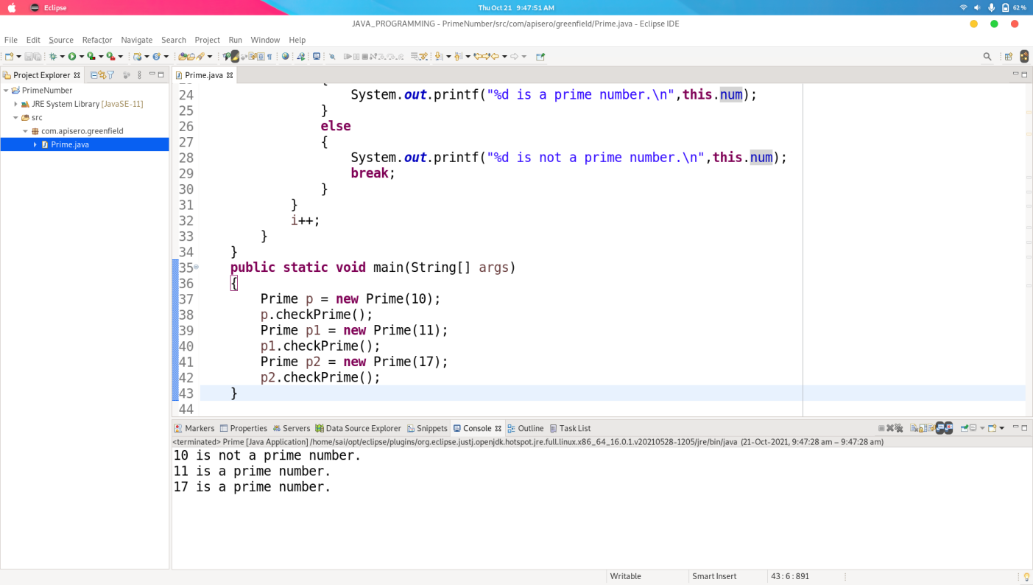

Title: 3. Program to check weather number is Armstrong number or not.

**Source Code:**

**package** com.apisero.greenfield;

**import** java.util.Scanner;

**public** **class** Armstrong

{

**boolean** checkArmstrong(**int** num)

{ **int** num2=num,i=0,sum=0,mult,value;

// to find the no. of digits in a number

**while**(num2!=0)

{

num2/=10;

i++;

}

// to find the armstrong value

num2=num;

**while**(num2!=0)

{

value= num2%10;

mult=1;

**for**(**int** j=1;j<=i;j++)

{

mult*=value;

}

sum+=mult;

num2/=10;

}

// to check the armstrong or not

**if**(sum==num)

{

**return** **true**;

}

**else**

{

**return** **false**;

}

}

**public** **static** **void** main(String[] args)

{

**int** num;

**char** ch='y';

Armstrong p = **new** Armstrong();

Scanner sc = **new** Scanner(System.***in***);

**while**(ch == 'y')

{

num = sc.nextInt();

**if**(p.checkArmstrong(num))

{

System.***out***.println("Number is an Armstrong Number");

}

**else**

{

System.***out***.println("Number is not an Armstrong Number");

}

System.***out***.print("Want to check Another Number: ");

ch = sc.next().charAt(0);

}

}

}

**Output:**

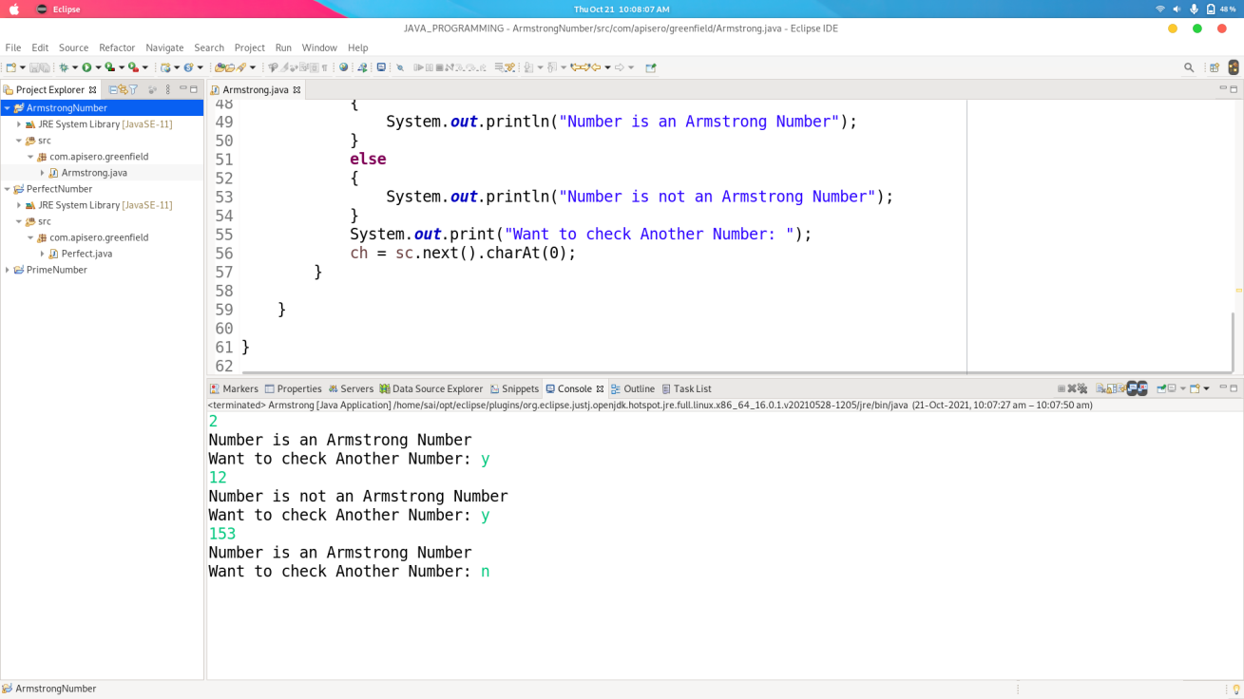

Title: 4. Program to print febonici series upto n numbers.

**Source Code:**

**package** com.apisero.greenfield;

**import** java.util.Scanner;

**public** **class** Fibonacii

{

**void** printFibonacii(**int** num)

{

**int** i=0,j=1,k;

**if**(num>0)

{

System.***out***.print(0+"\t");

}

**while**(num>1)

{

k=i;

i=i+j;

System.***out***.print(i+"\t");

j=k;

num--;

}

System.***out***.println();

}

**public** **static** **void** main(String[] args)

{

**int** num;

**char** ch='y';

Fibonacii p = **new** Fibonacii();

Scanner sc = **new** Scanner(System.***in***);

**while**(ch == 'y')

{

num = sc.nextInt();

p.printFibonacii(num);

System.***out***.print("Want to check Another Number: ");

ch = sc.next().charAt(0);

}

}

}

**Output:**

